|  |
| --- |
| **Philly CRM 311**  **Technical Design – Email**  **V1.2** |
|  |

# 1 REVISION HISTORY

|  |  |  |  |  |
| --- | --- | --- | --- | --- |
| **Revision Number** | **Revision Date** | **Summary of Changes** | **Author** | **Reviewer** |
| 1.0 | 06/15/2014 | All sections | Prabhakar/ Murugaboopathi |  |
| 1.1 | 03/10/2015 | Added Changes for Redress email template | Sreelatha SK | Catherine,  Marion Storey |
| 1.2 | 03/24/2015 | 2.2.5 - Do not send Close Case notification for “Miscellaneous” Case Record type  2.3 – For routing the Closed email cases to “New” when Customer replies | Sreelatha SK | Graham Quinn |
| 1.3 | 3/31/2015 | Updated based on Sheryl’s changes dated 26-Mar | Sreelatha SK | Graham Quinn |

1 REVISION HISTORY 2

2 Email 4

2.1 Overview 4

2.2 Email Template 4

2.2.1 Email template for Service Request Confirmations 4

2.2.2 Email template for Service Request Notifications 5

2.2.3 Email template for Service Request Escalations 6

2.2.4 Email template for Queue Members 7

2.2.5 Email template for Service Request Status Change 8

2.2.6 Email template for Redress Service Request 8

2.3 Email Channel 10

2.4 Email Template Matrix 11

2.4.1 Email Auto Response Rule 12

2.4.2 Email Alert 12

# 2 Email

## 2.1 Overview

The purpose of this document is to provide setting up email templates, email auto response rules and configuring email to case.

## 2.2 Email Template

Email templates are used to send an email from the Activity History related list of a record or from the Email section of the record. Email template is used for replying to individual customer’s request or inquiry, sending Mass Emails to users when an emergency situation arises, to communicate neighborhood meetings, etc..,.

Email templates are created under the folders below.

Name of the folders for all the template reside: Unfiled Public Email Templates, Philly311 Email Templates

**QUESTION: WHAT IS THE IMPACT OF THIS WHEN NEW EMAIL FOLDERS ARE CREATED?**

## 2.2.1 Email template for Service Request Confirmations

Email Template configuration details

Name : SUPPORT: Confirmation of your Case

Folder Name :

Subject : Confirmation of your Case

Email Body : TBD

Workflow Criteria : All Case Record Types, except “Miscellaneous”

Sample Config:

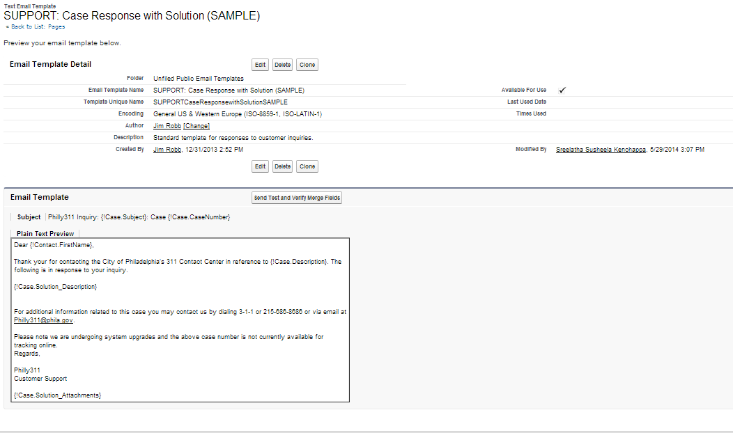

## 2.2.2 Email template for Service Request Notifications

Email Template configuration details

Name : SUPPORT: Case Notification

Folder Name :

Subject : Notification of your Case

Email Body : TBD

Workflow Criteria: All Case Record Types, except “Miscellaneous”

Sample Config:



## 2.2.3 Email template for Service Request Escalations

## WE DO NOT WANT THIS TEMPLATE TO BE AUTO-GENERATED.

Email Template configuration details

Name : SUPPORT: Case Escalation

Folder Name :

Subject : Case Escalation

Email Body : TBD

Sample Config:

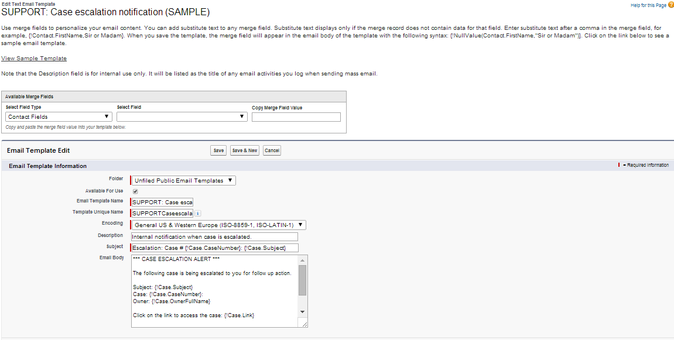

## 2.2.4 Email template for Queue Members

Email Template configuration details

Name : SUPPORT: Case Escalation

Folder Name :

Subject : Case Escalation

Email Body : TBD

Sample Config:

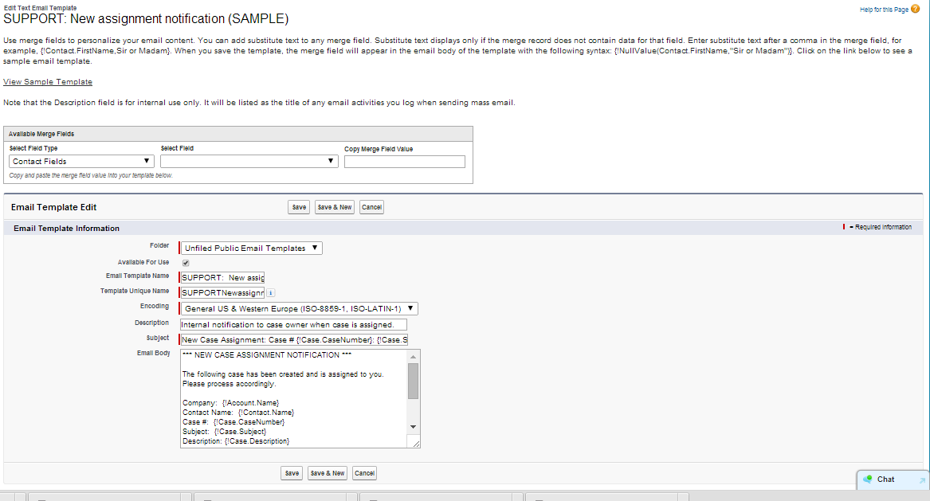

## 2.2.5 Email template for Service Request Status Change

Email Template configuration details

Name : SUPPORT: Case Closed

Folder Name :

Subject : Case Closed

Email Body : TBD

Sample Config:

Workflow Rule Criteria: TEXT(Status) = 'Closed' && ISCHANGED(Status) && NOT(ISPICKVAL(Case_Record_Type__c, 'Miscellaneous'))

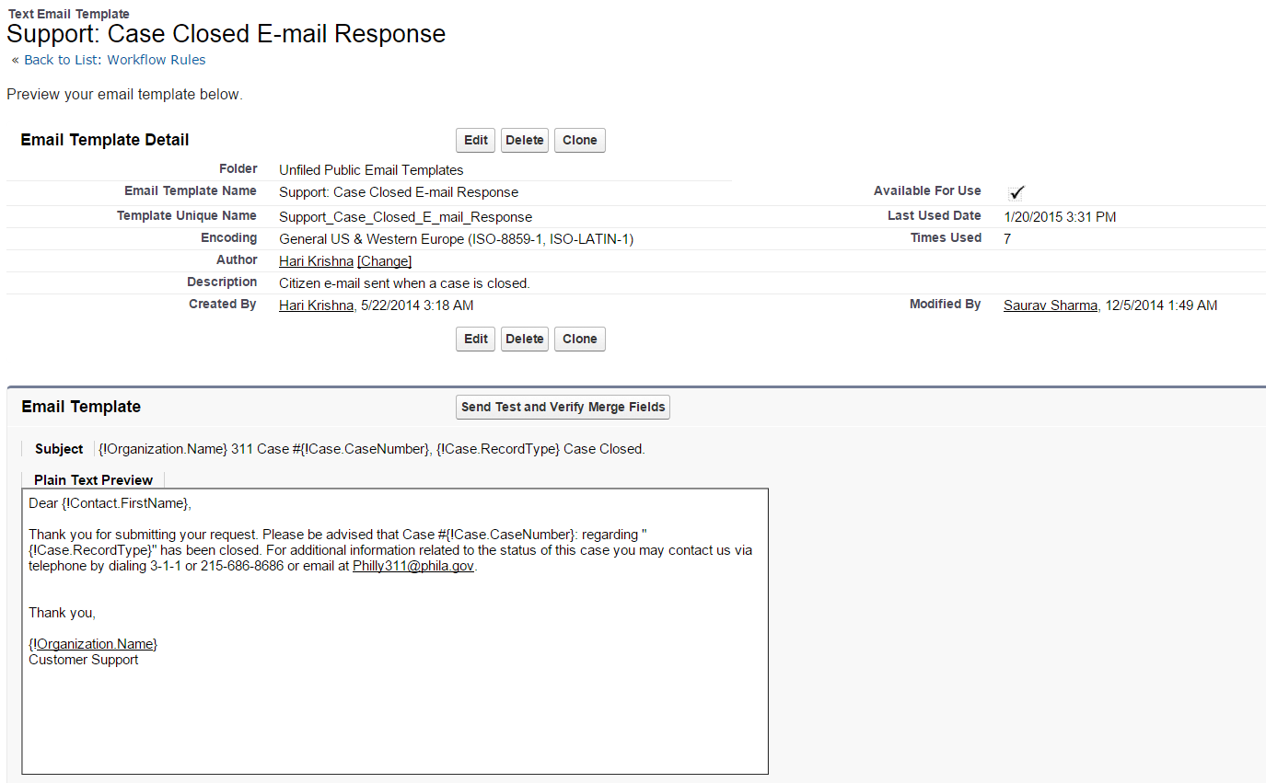

## 2.2.6 Email template for Redress Service Request

Email Template configuration details

Name : SUPPORT: Redress Case New assignment notification

Folder Name :

Subject : REDRESS CASE --- Streets ID # {!Case.Streets_Request_ID__c}: {!Case.Service_Request_Type__c} at {!Case.Street__c}

Email Body :

*** NEW CASE ASSIGNMENT NOTIFICATION FOR REDRESS CASE ***

**HOW DO WE HAVE A WORKFLOW THAT ENABLES US TO CUSTOMIZE REDRESS TEMPLATES FOR OTHER DEPARTMENTS?**

The following request has been submitted as a Redress to a previous service request that was closed by the Streets Department but reported to 311 as incomplete. Please investigate to determine current status and follow up promptly.

Redress Case

Streets ID #: {!Case.Streets_Request_ID__c}

Case #: {!Case.CaseNumber}

Date/Time Open: {!Case.CreatedDate}

Request Type: {!Case.Service_Request_Type__c}

Comments: {!Case.Description}

Address: {!Case.Street__c}

Contact Name: {!Contact.Name}

Contact Number: {!Contact.Phone}

Email Address: {!Contact.Email}

District Info:

Original Case

Original Streets ID #: {!Case.Redressed_Street_Request_Id__c}

Original Case #: {!Case.Parent}

Date/Time Open: {!Case.Redressed_Case_Date_Time_Open__c}

Comments:{!Case.Redressed_Case_Comments__c}

Case Resolution:{!Case.Redressed_Case_Reason__c}

Click on the respective link to access the case:

Internal Users: {!Case.Link}

Partner Users: https://philly.force.com/internal/{!Case.Id}

Thank you,

Philly311

Customer Support

Sample Config:

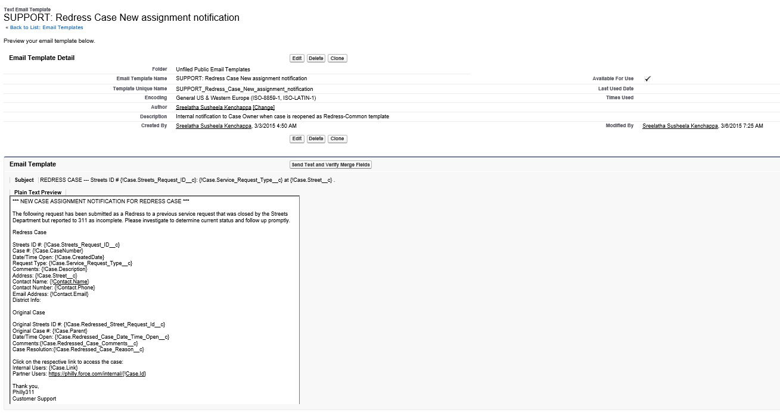

## 2.3 Email Channel

Email to Case is used to create a Case automatically in Sales force when customer send email to an email address.

**THIS STATEMENT IS NOT CLEAR.**

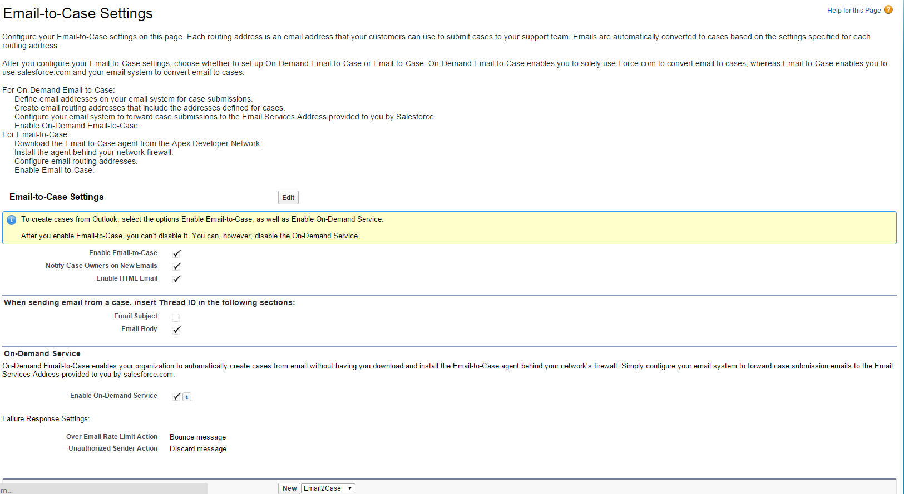

Routing Name : Philly311

Email Address : Philly311@phila.gov

Task Status : Open

~~Case Priority : 5~~

Case Origin : Email

Case Record Type : Miscellaneous

Workflow Rule : If Customer Reply to **Closed** case, the case should be routed to

“**311 CONTACT CENTER**” Queue with Case Status “**New**”.

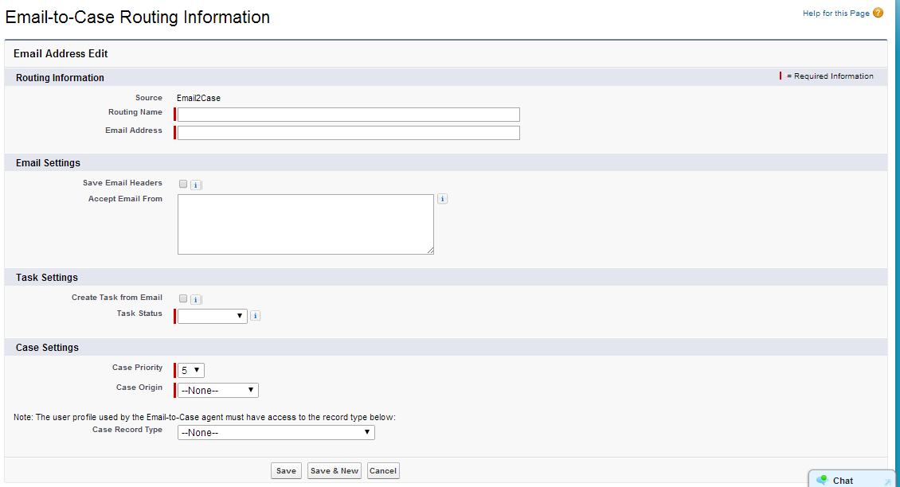

## ~~2.4 Email Template Matrix~~

|  |  |  |  |  |  |  |  |
| --- | --- | --- | --- | --- | --- | --- | --- |
| ~~Template Name~~ | ~~Type Of Email Template~~ | ~~Email Layout~~ | ~~Letter Head~~ | ~~Merge Fields~~ | ~~Case Auto-Response Rule~~ | ~~Email alerts~~ | ~~Description~~ |
| ~~Support: Case Closed E-mail Response~~ | ~~Text~~ | ~~None~~ | ~~None~~ | ~~Contact Fields~~ |  |  |  |
|  |  |  |  |  |  |  |  |
|  |  |  |  |  |  |  |  |
|  |  |  |  |  |  |  |  |

## ~~2.4.1 Email Auto Response Rule~~

**IS THIS BLANK BECAUSE WE DO NOT WANT AUTO-GENERATED RESPONSES FOR CASES RECEIVED VIA EMAIL?**

~~Name :~~

~~Sort Order :~~

~~Criteria :~~

~~Email Address :~~

~~Reply-To-Address :~~

## ~~2.4.2 Email Alert~~

~~Name :~~

~~Object :~~

~~Recipient Type :~~

~~Recipients :~~

~~From Email Address :~~

~~Workflow Rule using this action :~~